**NORTHERN VIRGINIA TRANSPORTATION AUTHORITY**

**M E M O R A N D U M**

**TO:** Chairman Martin E. Nohe and Members

Northern Virginia Transportation Authority

**FROM:** Michael Longhi, Chief Financial Officer

**DATE:** November 2, 2018

**SUBJECT:** Investment Portfolio Report

1. **Purpose:** To provide the Northern Virginia Transportation Authority (NVTA) with required reports on investment activities and portfolio performance through September 30, 2018.
2. **Background:**
3. This report is on investment activity through September 2018 and affirms the portfolio investments were acquired on the basis of safety, liquidity and then yield. This report summarizes the portfolio structure, and adherence to the NVTA Investment Policy.
4. Additionally, a monthly report is attached which complies with all reporting requirements prescribed in the NVTA Investment Policy.
5. **Current Period Reports:**
6. The safety of the portfolio is reflected in the actual composition of the portfolio as shown below:

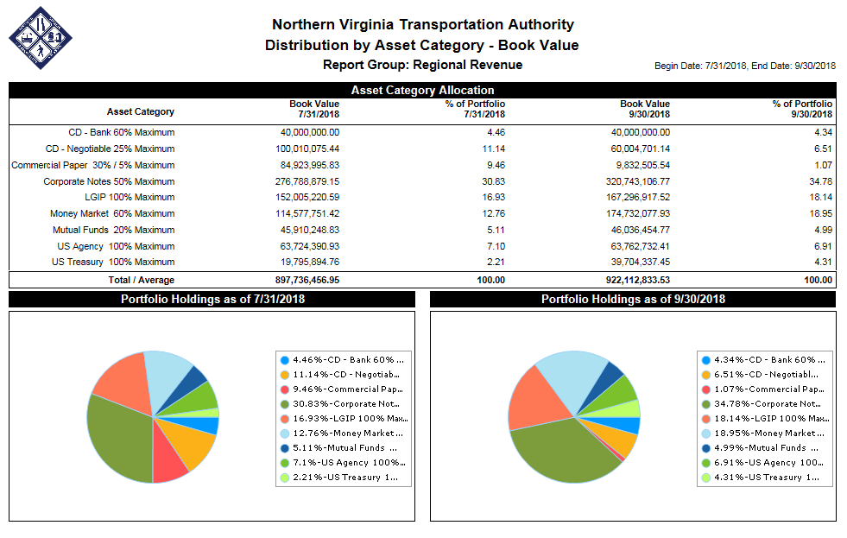

1. The liquidity of the portfolio is reflected in the portfolio’s duration of .43 (1.0 = 1 year) and the maturity schedule shown below:

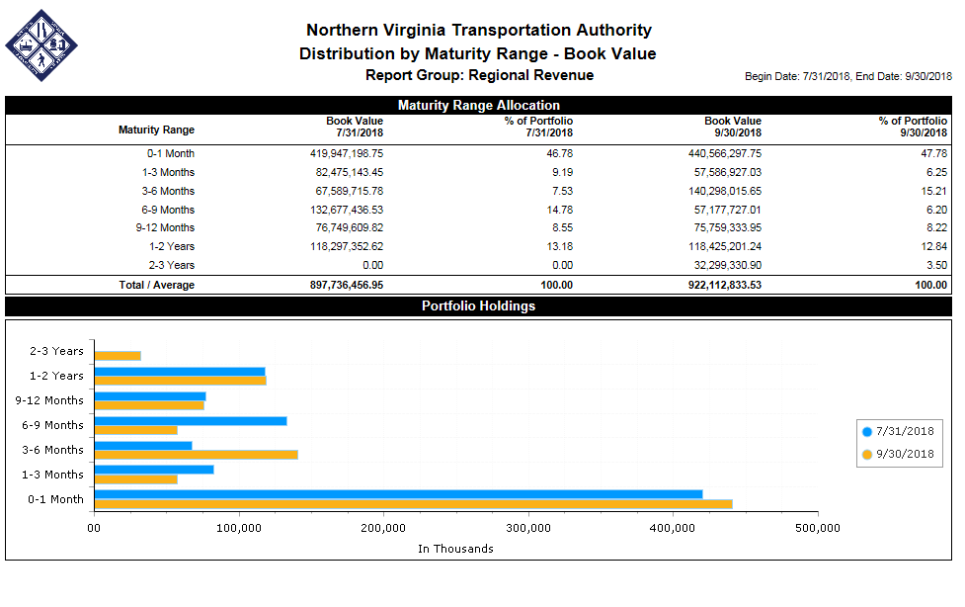

1. The yield on the portfolio at the end of September 2018 was 2.17%. The NVTA’s Investment Policy specifies the benchmarks shown below for yield performance comparison:



1. **Portfolio Analysis & Statistics Overview**
   1. **Safety:** The portfolio is invested primarily in;

**i)** AAA/AA rated investment grade corporate bonds

**ii)** Liquid Government Investment Pools (LGIPs) and;

**iii)** Collateralized bank money market accounts.

* 1. **Liquidity**:
     1. The NVTA Portfolio average duration is under 6 months (.43). Given the flat yield curve, however, the NVTA has not sacrificed yield by investing in short maturities or pursuing a short duration strategy (nearly 50% of the portfolio is in 0-3 Month Maturities).
     2. Analysis of forward transportation project liabilities (reimbursements) associated with the Six Year Program found that the portfolio has the flexibility to extend modestly to 2-3 year maturities (3.55% of the portfolio at present).
  2. **Yield:** 
     1. Federal Reserve Raises Rates: The Federal Funds Rate was raised to a range of 2% to 2.25% at the Federal Open Market Committee Reserve Meeting in late September. The November Investment Report will reflect a step up in performance during October as NVTA has obtained greater yielding Agencies and Treasuries instruments in the average range of 2.87% (as high as 3.01%) as a result of the Fed rate increase.

1. **Custodian/Safekeeping:** BB&T Retirement & Institutional Services is the custodian of all of NVTA’s investment purchases and is where all of NVTA’s non-deposit investments are held. Deposit type investments are protected through the Commonwealth of Virginia collateralization program or FDIC Insurance.
2. **Policy Required Reports:** The attached Compliance - GASB 40 Report addresses specific Investment Policy requirements regarding the purchase and holding of securities. The attached report, documents:
   1. **Compliance – Investment Policy, Summary.** The report shows the percentage of the portfolio by each type of investment.
   2. **Investment Portfolio – By Maturity Range.** The report shows the yield to maturity, and percentage of the portfolio which each type of investment represents.
   3. **Portfolio Holdings by Custodian**. This report shows each depository, investment firm or custodian holding NVTA securities or cash.
3. **Investment Repositioning, Exiting the VIP 1-3 High Quality Bond Fund:**
   * 1. **Reposition Plan Update:** The VIP1-3Bond Fund was exitedon September 28, 2018 with a mark-to-market loss of $842,554.07 that was an $89,332 higher loss than forecast. The recovery of the mark-to-market loss will occur in 1 year. Two occurrences are related to the greater than expected Mark to Market loss:
        1. The Federal Reserve increased rates .25%, just prior to the redemption. While this increased the mark to market loss it also increased the reinvestment opportunity.
        2. The VIP fund manager has total discretion as to which investments were sold to redeem our shares.

Taking advantage of the Federal Reserve rate increase, the proceeds of $46 million were reinvested the following week in various higher yielding investments, such as U.S. Treasuries, J.P. Morgan commercial paper, Federal Agencies such Freddie Mac, as well as highly rated corporate bonds such as BlackRock.

The new investments have an average yield of 2.86%, as compared with the VIP 1-3 which has delivered a gross total return of 1.21% (.43% annualized). The new investments are producing more than twice the gross total return and 6 times the annualized.

**Attachments:** Compliance - GASB 40 Report shows reporting requirements as listed above, and not otherwise presented. This report is also fundamental for the Authority’s Annual Financial Statements and annual audit.